



Conversion Factory - Manual Conversion Support requirements

System Requirement Specification

Document version: v3

DRAFT

**Table of Contents**

1. Overview 3

1.1. Purpose 3

1.2. Audience 3

1.3. Assumptions 3

1.4. Out of Scope 3

1.5. Referenced Documents 4

1.6. Terms and Acronyms 4

2. Conversion Factory requirements for Manual Conversion Support 5

2.1. Policy on renewal data import job 5

2.2. New business quote data import job 5

2.3. MCS job configuration options 5

2.4. MCS predefined data set 5

2.5. Data validation 8

2.5.1. MCS predefined data set validation 8

2.5.2. Constraints validation for additional fields 9

2.6. Customer/Account data 9

2.6.1. Create new Customer/Account or search for existing Customer/Account 9

2.6.2. Customer type 9

2.6.3. Create new Customer/Account 9

2.7. Create New Business quote 10

2.8. Create Renewal quote 11

2.9. Create Billing Account for policy import on renewal 12

3. Process Flow 13

3.1. Manual Conversion Support for new business quote 13

3.1. Manual Conversion Support for policy on renewal 13

4. Appendix 14

4.1. Project Specific - Extensions of Manual Conversion Support 14

4.2. Mapping of AAA specific legacy products to AAA EIS PAS products 14

5. History of Revisions 15

# 1. Overview

## Purpose

The purpose of this document is to provide requirements specification and adequate details to accommodate design and development of Manual Conversion Support (MCS) in EIS PAS and in Conversion Factory.

## Audience

The intended audiences for this document are:

EIS Group Business Team;

EIS Group Technical Teams;

EIS Group Quality Assurance Teams.

## Assumptions

1. The initial implementation for AAA will be based on EIS 5.2 release.  Subsequent EIS product releases will support MC as well;
2. Manual Conversion Support is not specific to one policy product or rating algorithm, but the initial implementation will be based on EIS Preconfigured Home product version 5.2.x;
3. Manual Conversion Support will utilize EIS default product XSD schema (currently used by Conversion Factory) which is a product specific schema;
4. All data validation that is required for Manual Conversion Support will be implemented via product rules that will be added to EIS PAS application and will be configured to be validated only on ‘On MCS Import’ event. This new event will be designated only for EIS Import batch jobs that will be developed for Manual Conversion Support;
5. EIS PAS products will be extended to add a new policy level field ‘convType’ with the lookup values ”Automatic “and ”MCS” to be able to identify quote/policy imported via EIS MCS import process or imported via automated EIS import jobs;
6. EIS PAS application will allow a user to complete Data Gathering process for quote/policy imported via MCS data import process using standard EIS PAS application UI;
7. New Business and Renewal quotes created using MCS data import process will undergo the same processing as regular quotes and policies;
8. A user will be able to search, view and edit quotes/policies created via MCS data import process using regular EIS PAS application UI;
9. EIS PAS application will not support editing of the previous term information.  If additional information is required to be added for a previous term it will need to be implemented as an extension and additional mandatory fields will need to be added to MCS

## Out of Scope for MCS

1. Any specifics related to EIS products developed as part of customer projects;
2. Any additions to MCS that are implemented as part of customer projects (Appendix -‘Extension of Manual Conversion Support’).
3. Changes to terms other than the current term for the imported quote/policy

## Referenced Documents

1. EIS Suite 5.2 product documentation, [https://www.eisuniversity.com/](https://www.eisuniversity.com/#recover-0b4fed1d0fe082ddfbfd8527ec0b6615);
2. Technical Overview document for Conversion Factory (EIS Suite 5.2), <https://wiki.exigeninsurance.com/display/CCOE/Import+Technical+Overview>.

## Terms and Acronyms

| **Term/Acronym** | **Definition** |
| --- | --- |
| EIS | EIS Group |
| EIS Suite | EIS product suite that consists of several sub-products |
| EIS PAS | PolicyCore Policy Administration System, part of EIS Suite |
| CF | Conversion Factory, part of EIS Suite |
| Data Conversion | Data migration from a source/legacy system to a target system |
| Automated Import | An option to initiate Data Conversion to PAS automatically by providing valid XML file that contains source system data |
| STUB policy approach | The approach supported by PAS that allows to import policy data at renewal using a STUB policy to represent the  previous term |
| Coexistence | Period of time for which one of legacy systems and PAS will run in parallel |
| Policy Import process | EIS CF Automated Policy Import process that automate Policy Import to EIS via XML file upload |
| Standard PolicyCore functionality | PAS functionality or features implemented for a policy product as EIS Suite behavior |
| Conversion Day 1 | The date when policy conversion on renewal starts in production |
| Renewal Quote | Quote pending Renewal (prior to Issue) for policy’s Renewal Term |
| Imported Renewal Quote | Renewal Quote created as a result of Automatic Conversion of the source system policy up for renewal |
| MEH | EIS Suite Conversion Factory’s Manual Exception Handling functionality that allows to ignore failure during Import process (see details in Technical Overview document) |
| UW rule | Underwriting rule that have ability to be overridden(UW Authority Level is defined) on validation failure |

# Conversion Factory requirements for Manual Conversion Support

Two new Conversion Factory import jobs will be created to support import of a predefined set of data supported by MCS - one job for import of new business quotes, another job for import of policies on renewal.

These jobs will be implemented as scheduled batch jobs that accept incoming XMLs, perform required data validation, persist a partial quote/policy image in EIS PAS database, log information about import process steps performed and return XML formatted response file describing import process results.

Each XML file will contain only one instance of quote/policy and its related data.

## Policy on renewal data import job

As a result of a successful import of MCS predefined policy data (see section ‘MCS Predefined data set’) a new imported Renewal quote will be created in EIS PAS using standard Conversion Factory “STUB policy approach”.

The imported Renewal quote will be saved in “Data Gather” status. The user can manually open regular Data Gathering UI for a renewal quote and proceed with data entry of remaining fields.

## New business quote data import job

As a result of successful import of MCS predefined quote data (see section ‘MCS Predefined data set’) a new business quote will be created in EIS PAS.

The imported new business quote will be saved in “Data Gather” status. The user can manually open regular Data Gathering UI for a new business quote and proceed with data entry of remaining fields.

## MCS job configuration options

Standard automated EIS data import job configuration option will be supported by MCS data import jobs.

## MCS predefined data set

| **Field Name** | **MCS Import jobs**  **(NewBusiness, Renewal)** | **MCS required** | **Condition for MCS Minimal?** | **Used in?** | **Description** | **Notes** |
| --- | --- | --- | --- | --- | --- | --- |
| Product Code | NewBusiness / Renewal | Yes | N/A | Policy data | Required to be part of XML file to perform related Import processing |  |
| Effective Date | NewBusiness / Renewal | Yes |  | Policy data: General | *) NB quote: 1st term's Effective Date to create New Business quote *) Renewal quote: renewal term's Effective Date to create Renewal quote |  |
| Term | NewBusiness / Renewal | Conditional Yes | If Expiration Date is not in XML file | Policy data | Mandatory if Expiration Date is not provided in XML file |  |
| Expiration Date | NewBusiness / Renewal | Conditional Yes | If Term is not in XML file | Policy data: General | Mandatory if Term is not provided in XML file  *) NB quote: 1st term's Expiration Date to create New Business quote *) Renewal quote: renewal term's Expiration Date to create Renewal quote |  |
| Producer | NewBusiness / Renewal | Yes | N/A | Assignment to the Agency (Policy) | The agency/location assigned to quote/policy   Agency, producerCd |  |
| Sub Producer | NewBusiness / Renewal | Yes | N/A | Assignment to the Agency (Policy) | The agent assigned to quote / policy  Agent, subProducerCd |  |
| Customer Type | NewBusiness / Renewal | Yes | N/A | New Customer | CustomerType can be either “IND”(Individual) or ”NONIND”(Not Individual) |  |
| First Name | NewBusiness / Renewal | Conditional Yes | Only when CustomerType=INDV | New Customer, Policy: Insured | Required for a new Customer creation (INDV) |  |
| Middle Name | NewBusiness / Renewal | Optional | N/A | New Customer Policy: Insured | This field is optional, but it should be included in the import it along with First Name & Last Name, if available |  |
| Last Name | NewBusiness / Renewal | Yes | Only when CustomerType=INDV | New Customer Policy: Insured | Required for a new Customer creation (INDV) |  |
| Non-Individual Type | NewBusiness / Renewal | Conditional  Yes | Only when CustomerType=NONINDV | New Customer | General Information, Non-Individual Type  Required for a new Customer creation (NONINDV) |  |
| Name – Legal | NewBusiness / Renewal | Conditional  Yes | Only when CustomerType=NONINDV | New Customer | General Information, Name – Legal  Required for a new Customer creation (NONINDV) |  |
| EIN | NewBusiness / Renewal | Conditional Yes | Only when CustomerType=NONINDV | New Customer | Business Information, EIN [Employer Identification Number]   Required for a new Customer creation (NONINDV) |  |
| Date business started | NewBusiness / Renewal | Conditional  Yes | Only when CustomerType=NONINDV | New Customer | Business Information, Date business started  Required for a new Customer creation (NONINDV) |  |
| Division | NewBusiness / Renewal | Conditional  Yes | Only when CustomerType=NONINDV | New Customer | SIC Classification, Division  Required for a new Customer creation (NONINDV) |  |
| SIC Code | NewBusiness / Renewal | Conditional  Yes | Only when CustomerType=NONINDV | New Customer | SIC Classification, SIC Code  Required for a new Customer creation (NONINDV) |  |
| Address Line 1 | NewBusiness / Renewal | Yes | N/A | New Customer, Policy: Insured | Address Info  Required for a new Customer creation (for both Customer Type = INDV/NONIND) | It is assumed that address validation is performed prior to import into PAS ( see section - Extension of Manual Conversion Support) |
| Address Line 2 | NewBusiness / Renewal | Yes | N/A | Policy: Insured; New Customer | Address info |  |
| City | NewBusiness / Renewal | Yes | N/A | Policy: Insured,  New Customer | Address info |  |
| State | NewBusiness / Renewal | Yes | N/A | Policy: Insured; New Customer | Address info |  |
| Zip | NewBusiness / Renewal | Yes | N/A | Policy: Insured,  New Customer | Address info |  |
| DueDate | Renewal | Optional | N/A | Billing Info | If DueDate is not provided, default value will be used | An option to import Billing specific data |
| Overpayment Option | Renewal | Optional | N/A | Billing Info | If not provided, default value “Next Installment” will be used |  |
| Payment Method - Electronic Funds Transfer | Renewal | Optional | N/A | Billing Info |  |  |
| Payment Method - PCI Credit Card | Renewal | Optional | N/A | Billing Info |  |  |
| Payment Method - Credit Card | Renewal | Optional | N/A | Billing Info |  |  |
| enableRecurringPayments | Renewal | Optional | N/A | Billing Info | If not provided, default value “false” will be used |  |
| enableRecurringPayments – default Payment Method | Renewal | Conditional Yes | enableRecurringPayments = “true” | Billing Info |  |  |
| Original Policy Effective Date | NewBusiness / Renewal | Optional | N/A | Policy: not UI | The effective date of policy’s first term; it can be default to current if it does not exists in legacy system (‘inceptionDate’) | An option to import additional data |
| Source Policy Nr | NewBusiness / Renewal | Optional | N/A | Cross reference info | ‘preConversionPolicyNumber' exists in Policy entity  Mandatory if required for Cross reference info between Source & PAS system policies | Optional may be changed to required as customer specific modification if required for cross referencing between Source & PAS system policies (see section - Extension of Manual Conversion Support ') |
| Renewal Term Premium | NewBusiness / Renewal | Optional | N/A | Not UI field, used if Premium Compare rules are set up | Annual Premium calculated in the source system on renewal image data (aged policy) - ‘preConversionPolicyPremium’(used in Premium Compare rules)  Specifically indicated Annual premium to allow comparison with our calculated premium |  |
| importedFrom | NewBusiness / Renewal | Optional |  |  |  |  |

## Data validation

### MCS predefined data set validation

During the MCS data import process the following validations should be performed as part of MCS import jobs and applied to MCS predefined data:

1) All mandatory fields identified in section ‘MCS predefined data set’ (see column ‘MCS Required’, values “Yes” and “Conditional”)

2) MCS predefined data set field values should comply with product constraints and lookups that are defined in the product

3) The following additional validations should be applied:

1. ‘Effective Date’ should be before ‘Expiration Date’;
2. ‘Effective Date’ should be after or equal to ‘Original Policy Effective Date’;
3. Product Code should be valid and correspond to EIS/Customer product defined in EIS/Customer PAS application.

If data validations specified above will fail for any of fields specified in MCS predefined data set quote/policy data will be rejected and corresponding error(s) will be logged in the system.

### Constraints validation for additional fields

EIS core service ConstraintsRulesInvocationService is applied to the quote/policy object to verify field constraints: mandatory fields, value ranges, lookup values. The constraint validation is performed using product definition available in EIS Product Factory.

If product constraints validation fails for any additional fields or components included in the quote/policy data in addition to MCS predefined data set, by default configuration quote/policy data will not be rejected. It will be possible to configure MCS to reject quote/policy data in this scenario.

## Customer/Account data

### Create new Customer/Account or search for existing Customer/Account

During MCS data import process a new Customer/Account is created from the MCS predefined data set or quote/policy data is associated with the existing customer/account.

EIS BASE Default Customer Search method will be used to search for an existing Customer - ‘customerDao.findDuplicateCustomersByDefaultCriteria(customer)’

The following standard EIS Import options will be supported:

|  |  |
| --- | --- |
| CF property  (java beans) | Description |
| *searchExistingCustomer =* true/false | If true, import job will search for existing customer.  Import will search based on default EIS search criteria using data from import XML.  If customer is not found, the option createCustomer is used to determine next action.  If customer is not found and if createCustomer is false, then import will reject the customer import XML file.  If more than one customer is found matching search criteria, customer import XML is rejected with the corresponding error message:  CONV_ERR_215 – “There are more than one customer matching search criteria: %s” |
| *createCustomer= true/false* | If true, import job will create a customer from main insured.  If false, import job will not create a customer but reject data upload if customer search was not successful |

### Customer type

MCS import jobs should support a different search algorithm for an existing customer depending on the value of field “CustomerType’ (values “IND” or NONINDV).

### Create new Customer/Account

The following fields must be filled in the Customer component and the following approach should be used to create a new Customer component:

| **nr** | **Customer component** | **XML/Defaulted by import** | **Details** |
| --- | --- | --- | --- |
| 1 | Assignment  (assignment to the agency) | XML | ‘Producer Code/Sub-Producer Code’ from policy info (‘subProducerCd’) { EIS API “getProducerCd” } |
| 2 | Customer Type | XML | Either INDV or NONINDV { related to EIS lookup ‘CustomerType’} |
| 3 | Customer Name Info | XML | ‘NameInfo’ from policy’s main insured { EIS API method “getNameInfo”, “getMainInsured”} |
|  | Company Info | XML |  |
| 4 | Address Info | XML | ‘Mailing’ address (Lookup: PrecAddressType) is taken from policy’s main insured’s primary address { EIS API method “getAddress”, “getPrimaryAddressEntity”,“getMainInsured”} |
| 5 | QuoteCount | Default | Import will default a value to 1 if NewBusiness quote will be created at the end of Import process  Import will default a value to 0 if Renewal quote will be created at the end of Import process. |
| 6 | PolicyCount | Default | Import will default a value to 0 if NewBusiness quote will be created at the end of Import process  Import will default a value to 1 if Renewal quote will be created at the end of Import process. |

If a new Customer must be created then a corresponding Customer Account must be created using the following approach:

| **nr** | **Account component** | **XML/Defaulted by import** | **Details** |
| --- | --- | --- | --- |
| 1 | Broker | XML | ‘Producer/Sub-Producer Code’ from policy info (‘subProducerCd’) { EIS API “getProducerCd” } |
| 2 | Customer Account Name | Default | PAS default name creation will be used based on a new Customer info { EIS API "getDefaultAccountName" in 'CustomerAccount'} |
| 3 | Special Handling | Default | Default to FALSE |
| 4 | Confidential Account | Default | Default to FALSE |

## Create New Business quote

When a new business quote is created during MCS data import the following values will be defaulted to corresponding values from the table below if these values are not provided in the XML file:

| **UI field, ID** | **Quote**  (PAS term) | **Description, related LookUp** |
| --- | --- | --- |
| Effective Date,  XML | effectiveDate | Use XML value of ‘Effective Date’ |
| Expiration Date,  XML or calculated value | expirationDate | Use XML value of ‘Expiration Date’ or a date calculated using ‘Term’ |
| Term,  XML or empty | term | Use XML value if provided |
| N/A,  default value | createdBy = <ipbsysuser> | The system will default createdBy field to commonly used system id (<ipbsys>) |
| N/A,  value generated by the system | QuoteNr | The system should generate Quote Nr using PAS functionality |
| Policy Type,  default | policyType = "STD" | LookUp ‘typeOfPolicy’ values:  AR “Assigned Risk”;  STD “Standard/Voluntary” |
| N/A,  default value | Policy.Type = "ANN" | “ANN”, Anniversary |
| N/A,  default value | Policy.Status = “Data Gathering” |  |
| N/A,  default value | renewalCycle=0 |  |
| N/A,  XML or default value | inceptionDate | Use XML value of ‘Original Policy Effective Date’ or default to quote Effective Date if empty |
| N/A,  XML or empty | preConversionPolicyNumber | Use XML value of Legacy Policy Nr or leave it empty |
| N/A,  default value | imported = “New Business”  or “BookRoll” |  |
| N/A,  default | convType = “MCS” | The following lookup values: ”Automatic”, ”MCS” |

## Create Renewal quote

When renewal quote is created during MCS data import the following values will be defaulted to corresponding values from the table below if these values will not be provided in the XML file:

|  |  |  |  |
| --- | --- | --- | --- |
| **UI field, ID** | **STUB Policy**  (current term) | **Renewal**  (sub-sequent renewal term) | **Description, related LookUp** |
| Effective Date,  XML | effectiveDate | Use XML value of ‘Effective Date’ |  |
| Expiration Date,  XML or calculated value | expirationDate | Use XML value of ‘Expiration Date’ or a date calculated using ‘Term’ |  |
| Term,  XML or empty | term | Use XML value if provided |  |
| N/A,  default value | createdBy = <ipbsysuser> | The system will default createdBy field to commonly used system id (<ipbsys>) | The system will default createdBy field to user ID who started Manual Conversion |
| N/A,  value generated by the system | PolicyNr | PolicyNr | The system should generate Policy Nr & Quote Nr using existing functionality |
| Policy Type,  default | PolicyType = "STD" | policyType = "STD" | LookUp ‘typeOfPolicy’ values:  AR “Assigned Risk”;  STD “Standard/Voluntary” |
| N/A,  default value | Type = "ANN" | Policy.Type = "ANN" | “ANN”, Anniversary |
| N/A,  default value | Status =”Active”(if prior or on Expiration Date) or  ”Expired”(if after Expiration Date) | Policy.Status = “Data Gathering” | The values should be set up based on standard policy lifecycle |
|  |  |  |  |
| N/A,  XML value | ProductCd | productCd | PAS product (XML field ‘Product Code’) to which policy is converted from the legacy system |
| N/A,  default value | renewalCycle=0 | renewalCycle=1 | Currently: The system sets up renewalCycle to 1 once *converted Renewal Quote* is created for STUB policy |
| N/A,  system calculated | inceptionDate | inceptionDate | Use XML value for ‘Original Policy Effective Date’ or default to renewal’s Effective Date |
|  |  |  |  |
| N/A | preConversionPolicyNumber | preConversionPolicyNumber |  |
| N/A,  default value | imported = “CONV” | imported = “CONV” |  |
| N/A | convType = “MCS” | convType = “MCS” | the following lookup values ”Automatic”,”MCS” |

## Create Billing Account for policy import on renewal

A new billing account is created for imported policy and the following values will be defaulted to corresponding values from the table below if these values will not be provided in the XML file:

| **nr** | **Info on Billing Account** | **XML/Default** | **Details** |
| --- | --- | --- | --- |
| 1 | Overpayment Option | XML/Default | Use XML value or default to “Next Installment” if empty |
| 2 | DueDate | XML/Default | Use XML value or calculate default using Effective Date by EIS default method |
| 3 | Payment Methods | XML/none | Use XML data if provided |
| 4 | Recurring Payment | XML/none | Use XML data if provided |

# Process Flow

## Manual Conversion Support for new business quote

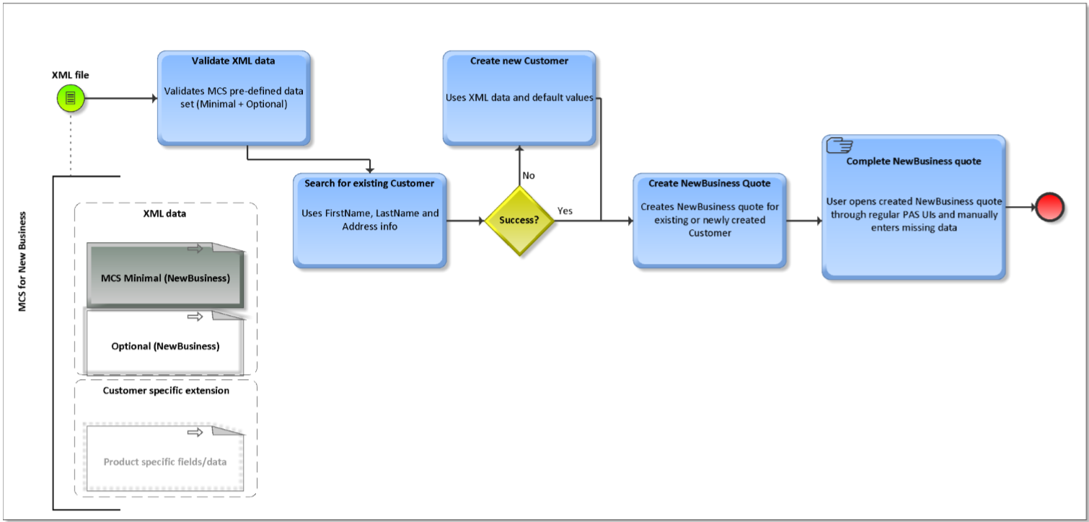

## Manual Conversion Support for policy on renewal

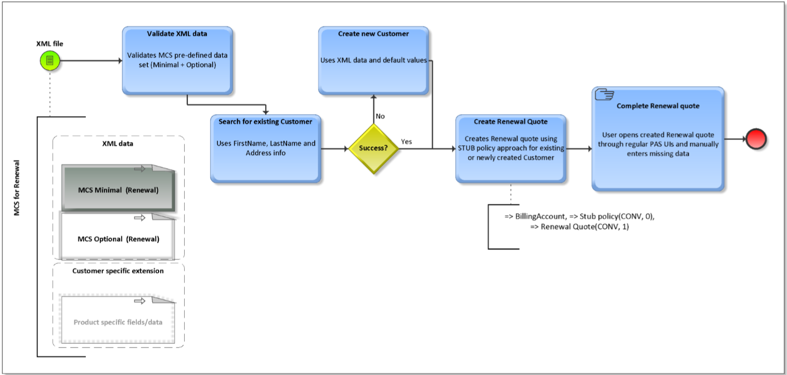

# Appendix

## Project Specific - Extensions of Manual Conversion Support

The following is considered part of project specific extension scope for EIS MCS:

1) Addition of any components or fields beyond MCS predefined data set defined in this document and corresponding validation

2) Address information cleanup and validation – the recommended approach is to perform address cleanup before data import into EIS PAS

3) Addition of fields and corresponding validations that are included in the EIS BASE preconfigured product to support MCS predefined data set if these fields are missing in the customer product

For example: adding Source System Policy Number, Expiring Term Premium, Line of Business, and Legacy Product Code to MCS predefined data set in the customer specific products

4) Addition of any components or fields and corresponding validations required to support Automated Capping in the customer specific products

## Mapping of AAA specific legacy products to AAA EIS PAS products

As per AAA high level requirements, MCS is required for the following products:

|  |  |  |  |
| --- | --- | --- | --- |
| **Legacy system** | **Legacy product** | **PAS product** | **Comment** |
| AS400 (SIS) | non-Signature Series auto policies | CA Select Auto(AAA_CSA) | Only CA Select Auto(AAA_CSA) as it is not Auto Signature Series (AAA_SS)  To confirm with AAA that it’s correct understanding of not Signature Series  Any other non-signature future Auto product products? |
| AS400 (SIS) | non-Signature Series property policies | California Homeowners(AAA_HO_CA) | California Homeowners(AAA_HO_CA) as it is not Homeowners Signature Series(AAA_HO_SS)  To confirm with AAA that it’s correct understanding of not Signature Series  Any other non-signature future Home products? |
| MAIG systems | non-Signature Series auto policies | CA Select Auto(AAA_CSA) |  |
| MAIG systems | non-Signature Series property policies | California Homeowners(AAA_HO_CA) |  |
| AS400 (SIS) | CA Choice policies |  | may be removed depending on decision to automate conversion of these |

# History of Revisions

Table : History of revisions

| History of revisions | | | | |
| --- | --- | --- | --- | --- |
| Revision date | Version | Author | Description | Chapter Changed |
| 1-Feb-2015 | v0.0.01 | Anna Pinne | Initial draft |  |
| 10-Feb-2015 | v.2.0.00 | Rowshi Pejooh | Feedback |  |
| 12-Feb-2015 | v.2.0.01 | Anna Pinne | Updates |  |
| 14-Feb-2015 | v.2.0.02 | Anna Pinne | Multiple updates, ready for internal team review |  |
| 17-Feb-2015 | v.2.0.03 | Anna Pinne | Added a few placeholder items that were discussed with Aigars and Georgs |  |
| 18-Feb-2015 | v2.0.04 | Anna Pinne | Updated based on internal review with Georgs & Andrejs, some ToDos and also need to update section 2.2 (similar on how updated 2.1) |  |
| 19-Feb-2015 | v2.0.05 | Anna Pinne | Updates to resolve ToDo items |  |
| 20-Feb-2015 | v2.0.06 | Anna Pinne | Multiple updates based on feedback from EIS Import team, also updated Premium fields to match Capping req-ts (aslo comment on rest of fields pointed out for Capping) |  |
| 24-Feb-2015 | v2.0.07 | Anna Pinne | 2.1. MCS predefined data set (separate Excel file to have ability to filter Minimal{mandatory, conditional-mandatory})  2.2. Validate XML data  5.1. Suggested MCS enhancements | 2.1, 2.2,5.1 |
| 25-Feb-2105 | v2.0.08 | Aigars Secis | Rewriting as per comments provide by reviewers |  |
| 26-Feb-2105 | v2.0.09 | Aigars Secis | Finalizing rewriting of the document |  |
| 26-Feb-2015 | v2.0.10 | Anna Pinne | A few updates on detailed field description and |  |
| 26-Feb-2015 | v2.0.11 | Anna Pinne | Incorporated Mark’s comments |  |